***HERBERT ARMSTRONG, 93, DIES; EVANGELIST AND A BROADCASTER***

**Special to the New York Times** JAN. 17, 1986

[[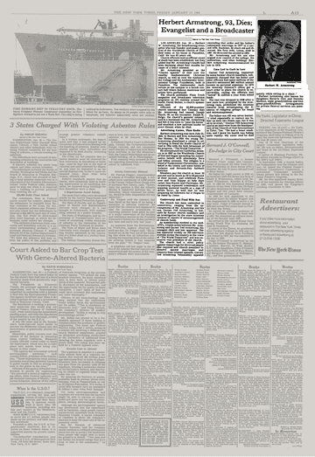](https://timesmachine.nytimes.com/timesmachine/1986/01/17/976486.html)](https://timesmachine.nytimes.com/timesmachine/1986/01/17/976486.html" \t "_blank)

**[VIEW PAGE IN TIMESMACHINE](https://timesmachine.nytimes.com/timesmachine/1986/01/17/976486.html" \t "_blank)**

January 17, 1986, Page 00015 The New York Times Archives

Herbert W. Armstrong, the broadcasting evangelist who was founder and pastor general of the Worldwide Church of God, died today at his home in Pasadena, Calif. He was 93 years old. Church officials said no official cause of death had been established, but they added that Mr. Armstrong's health had been declining about four months because of a heart ailment.

Mr. Armstrong presided as the ''Chosen Apostle'' of God over the wealthy fundamentalist Christian church, as well as over the Ambassador College and the Ambassador International College Foundation, both in Pasadena. The Ambassador Auditorium on the campus is a lavish concert hall where famous musicians and artists have performed.

The church publishes Plain Truth magazine and broadcasts television programs on 374 stations around the world, David Hulme, a church spokesman, said.

Officials of the 80,000-member church announced last Tuesday that Mr. Armstrong had named Joseph Tkach, 59, as his successor. Ralph K. Helge, the church's general counsel, said in a statement that Mr. Armstrong had felt it was time to ''pass the baton'' and establish a new spiritual leader to avert dissent when he died. Advertising Career, Then Radio

Herbert Armstrong was born July 31, 1892, to Horace and Eva Armstrong in Des Moines. In 1934 the young Mr. Armstrong abandoned a career in advertising to found the Radio Church of God in 1934 with the first broadcast of his program, ''The World Tomorrow.''

He incorporated his California ministry in in 1947 as the Worldwide Church of God and began spreading his conservative beliefs with alternately fiery and folksy sermons. The religion is a blend of fundamental Christianity, non-belief in the trinity and some tenets of Judaism and Seventh-Day Sabbath doctrine.

Members pay the church at least 10 percent and as much as 20 to 30 percent of their income, and celebrate Passover and Yom Kippur as holy days rather than Easter and Christmas. Mr. Armstrong espoused creationism and enjoying material wealth as a sign of divine favor; he held that he was preparing his followers for a Utopia to be ruled by Jesus. Controversy and Feud With Son

The church has been embroiled in controversy, ranging from the estrangement of Mr. Armstrong and his son, Garner Ted Armstrong, to lawsuits by former church members and an investigation by the state Attorney General of reports of mismanagement of church funds.

As membership swelled in the mid-1970's, trouble arose between Mr. Armstrong and Garner Ted Armstrong, his youngest child and heir apparent. The son appeared weekly on 165 television stations across the country as the voice of ''The World Tomorrow'' and was executive vice president of the church.

The church had a strict policy against remarriage for divorced people that required new church members to dissolve second marriages and remarry their original spouses. Garner Ted Armstrong vehemently opposed rescinding that order and his father's subsequent marriage in 1977 to a second wife, Ramona, 44 years old and divorced. His first wife, Loma, died in 1967. He divorced the second in 1984.

Mr. Armstrong and his son also argued over control of the college, the auditorium, and other holdings. Herbert Armstrong excommunicated his son in 1978. Case Led to Curb in Law

Garner Ted Armstrong, supported by some former church members, subsequently charged that his father and other officials had spent millions of the church's estimated $60 million annual income on personal expenses. In 1979 the Attorney General's office got a court order to place the church in receivership, saying the officials had ''looted'' $1 million a year from tithed funds.

The case was dropped in 1980 after a new state law, prompted by the Armstrong case, prohibited the Attorney General from investigating the finances of religious groups for fraud and mismanagement.

The father-son rift was never healed. ''I tried repeatedly to contact my father up until two weeks ago, but it was all to no avail,'' Garner Ted Armstrong said in an interview from the headquarters of his Church of God International at Tyler, Tex. ''He had a heart condition, and I knew his health was failing quite rapidly. My sister said he died quietly while sitting in a chair.''

Herbert Armstrong also leaves his daughters Beverly Gott and Dorothy Mattson, eight grandchildren and four great-grandchildren. Arrangements for private funeral services are pending.